Health Insurance Claim Management System Design

for Chen’s Chinese Medicine

Pan Chen

Syracuse University

I am designing a Health Insurance Claim Management System for my aunt, who runs a clinic in Camarillo, CA called Chen’s Chinese Medicine. The current one she is using is not too easy to use and not efficient enough: it has too much functions/options that an acupuncture clinic does not need, so it takes extra time to navigate through these redundant options input each patient’s entry. So a simple design that focuses on the insurance billing might be a good start point for my project.

My aunt is the only practitioner in the clinic with several other part-time staff members that helps her with insurance claim filing and billing. This project is set to help the clinic manage the patient’s payment to each office visit, which records the patient information and his/her insurance policy information, his/her office visits including appointment date and the description of the treatment, insurance claims associate with his/her visits and their statuses, the clinic staff that is responsible for handling each claim, and the medical bills that are not billable to insurance companies and thus need to be paid upfront.

**Section III**: entity and attribute table (see the following example table)

This section should include a table that lists all entities and their attributes, as well as necessary explanations of what data each entity stores. For foreign keys and associative entities, make sure to explain the relationships they establish. Please also provide explanations for the attributes that are hard to understand based on common sense. No need to provide explanations for easy-to-understand attributes like IDs, names, and addresses.

|  |  |
| --- | --- |
| Data object | Explanation |
| **Patient** | Patients’ personal information |
| PK: PatientID | Either DL/ID Number or Passport Number |
| PFirstName |  |
| PLastName |  |
| PAddress |  |
| PGender |  |
| PSSN | optional |
| PDOB |  |
| **Insurance** | Patients’ insurance information |
| PK: PolicyNo | Insurance Policy Number |
| FK: PatientID | Associates with PatientID in **Patient** Table, a patient could have one or more insurance policies, an insurance policy is only for one patient |
| InsCompany |  |
| InsProg | Insurance policy program |
| InsAddress | Insurance company address |
| InsPhoneNo | Insurance program phone number |
| StartDate |  |
| EndDate |  |
| **Visit** | Patients’ office visits information |
| PK: VisitID | Autogenerated |
| FK: PatientID | Associates with PatientID in **Patient** Table, a patient could have one or more visits, an office visit is only for one patient |
| VisitType | Type of visits, including Counseling, Medicine, Acupuncture, Cupping, and etc |
| VisitDesc | Describe the diagnosis/treatment |
| VisitDate |  |
| VisitTime |  |
| **NonInsuranceBill** | Non-Insurance bill: Medical bills not billable to the insurance company |
| PK: BillNo |  |
| FK: VisitID | Associates with VisitID in **Visit** Table, a visit could generate one or more visits, an office visit is only for one patient |
| FK: StaffID | Associates with StaffID in **Staff** Table, a Non-insurance bill is handled by one of the clinic staff, a staff member can handle multiple non-insurance bills |
| BillDate |  |
| BillAmt | The bill amount |
| BillDesc | Detailed Description on what the bill is about |
| PaidAmt | How much of the bill is paid |
| BillStatus | Whether the non-insurance bill is paid, paid in part, or not paid at all |
| BillPaidDate |  |
| **ClaimStatus** | Statuses of insurance claims |
| PK: StatusID |  |
| StatusDesc | Claim Status Description, which includes dispute, settled, not filed yet, pen |
| StatusDetail | Detailed description on what the status is about |
| **Staff** | Information about staff member including the doctor herself |
| PK: StaffID |  |
| StaffFirstName |  |
| StaffLastName |  |
| StaffPhoneNo |  |
| StaffEmail |  |
| **Claim** | Insurance Claim Information |
| PK: ClaimNo |  |
| FK: PolicyNo | Associates with PolicyNo in **Policy** Table, a claim can only be filed under one policy, a policy can have multiple claims |
| FK: VisitID | Associates with VisitID in **Visit** Table, a claim can only be filed for one policy, a visit can have multiple claims |
| FK: StatusID | Associates with StatusID in **ClaimStatus** Table, a claim can only have one status, a status could be from multiple claims |
| FK: StaffID | Associates with StaffID in **Staff** Table, a claim can only be filed by one staff, a staff can file multiple claims |
| ClaimDate | The date the claim is generated |
| SentDate | The date the claim is filed |
| SettleDate | The date the claim is settled |
| AmtClaimed | The amount asked by the clinic |
| AmtNegotiated | The final negotiated amount between the clinic and the insurance company |
| AmtPaidByIns | Amount of money paid by insurance |
| AmtPaidByPatient | Amount of money paid by the patient |

**Section IV**: **relational data model**

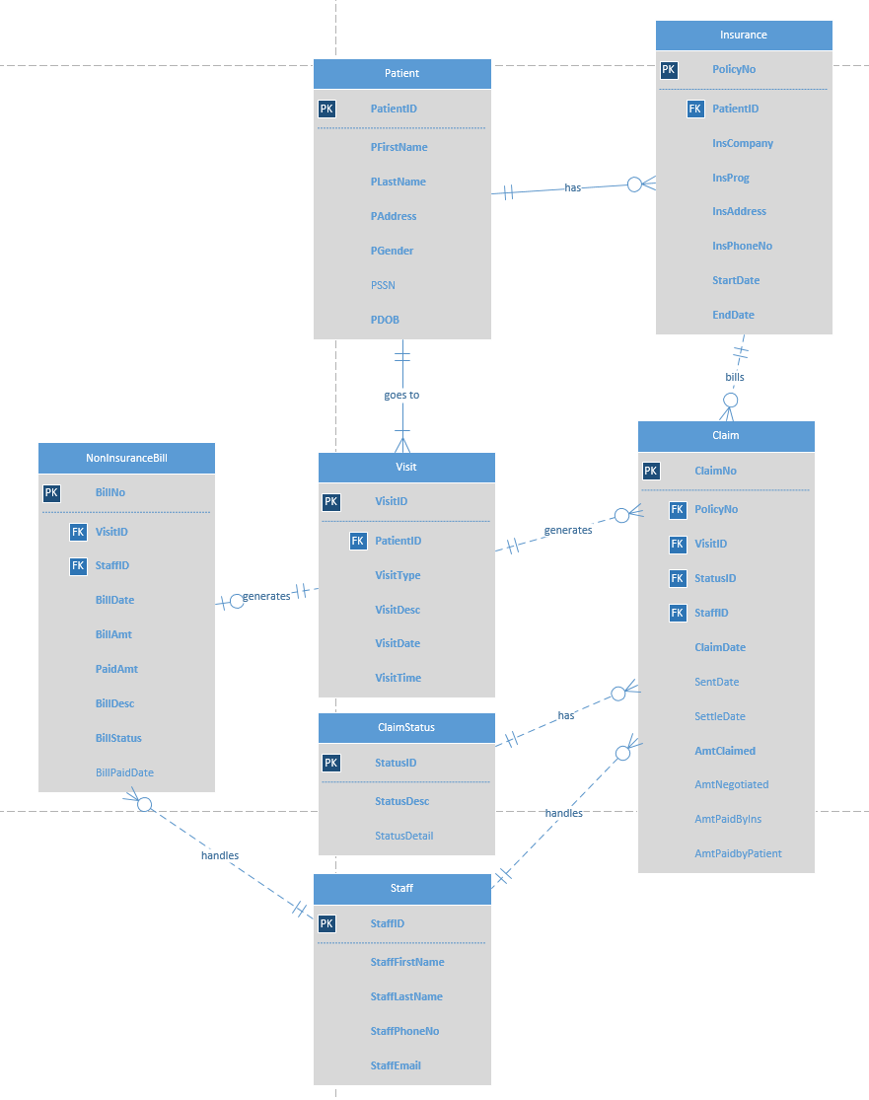

**Section V**: **business rules that are not represented in the above data model**

1. Each patient has to have an insurance policy, each policy number belongs to one patient, however it is up to the patient whether to use the insurance or not.
2. Claim Status Description(StatusDesc) can only be one of the four values: “D” stands for dispute, “S” stands for settled, “N” stands for not-filed -yet, “P” stands for pending.
3. Non-Insurance Bills can only be one of the four values: “O” stands for owed (paid in part), “S” stands for Settled, “N” stands for not-paid-yet.

**Section VI**: **major data questions?**

All clinic staff member could check the statuses of the insurance claims including whether the insurance claim is filed, whether it is settled, the settled amount, how long it usually takes for different types of claims to get settles, which insurance company and which insurance program reimburse the clinic with the highest rate, which insurance company processes the claims the fastest in general, so the doctor could decide which insurance company to take and which do not. It could also help the financing guys to determine how much tax should the clinic file, how much deductible could the clinic/staff/doctor claim, and so forth, and the State Board for the regulation purposes.